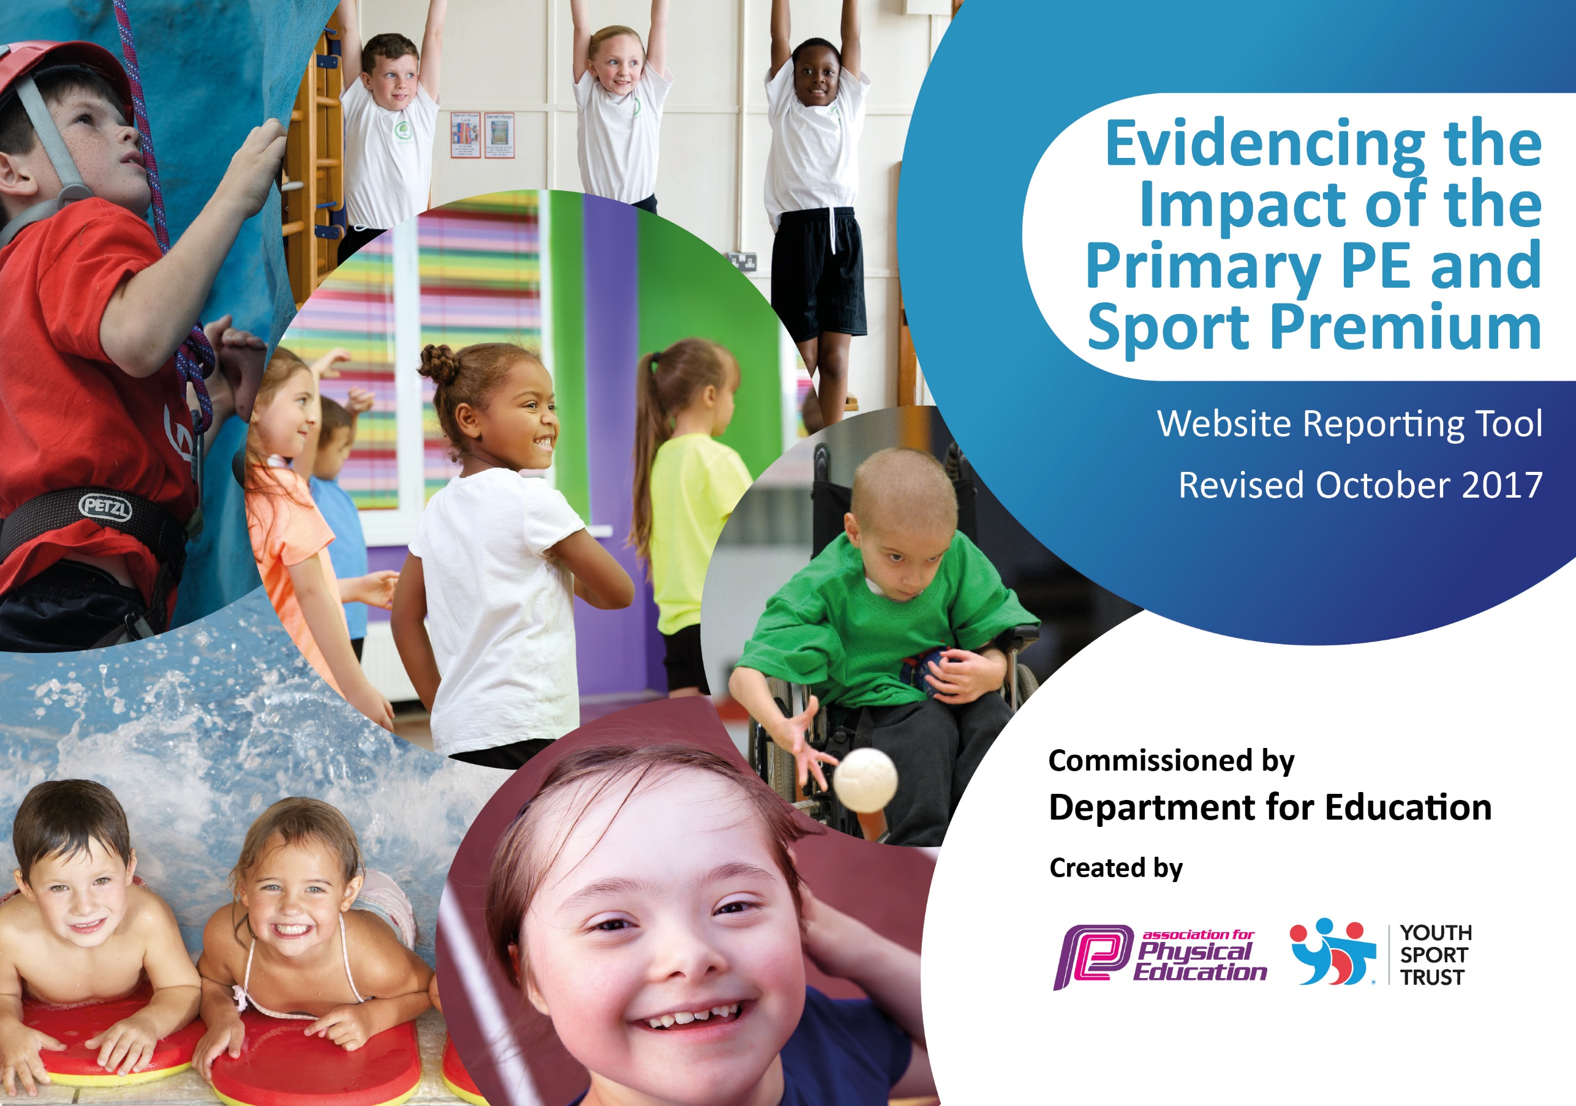

Schools must use the funding to make additional and sustainable improvements to the quality of PE and sport they offer. This means that you should use the Primary PE and Sport Premium to:

- develop or add to the PE and sport activities that your school already offers
- build capacity and capability within the school to ensure that improvements made now will benefit pupils joining the school in future years

Please visit gov.uk for the revised DfE guidance including the 5 key indicators across which schools should demonstrate an improvement. This document will help you to review your provision and to report your spend. DfE encourages schools to use this template as an effective way of meeting the reporting requirements of the Primary PE and Sport Premium.

We recommend you start by reflecting on the impact of current provision and reviewing the previous spend.
Under the Ofsted Schools Inspection Framework, inspectors will assess how effectively leaders use
the Primary PE and Sport Premium and measure its impact on outcomes for pupils, and how effectively governors hold them to account
for this.

Schools are required to publish details of how they spend this funding as well as on the impact it has on pupils’ PE
and sport participation and attainment.
We recommend regularly updating the table and
publishing it on your website as evidence
of your ongoing review into how you are using the money
to secure maximum, sustainable impact. To see an example of how to complete the table please click HERE.

Support for review and reflection - considering the 5 key indicators from DfE, what development needs are a priority for your setting and your students now and why? Use the space below to reflect on previous spend, identify current need and priorities for the future.

Key achievements to date: | Areas for further improvement and baseline evidence of need:
High 5 Netball Yr 5/6 Champions 2016  Runners up Sportshall Athletics 2016  Quicksticks Hockey Yr 3/4 Champions 2017  Tennis Yr 3/4 Large School Champions 2017  Duathlon Yr 4, 5, 6 2016 3 Golds, 2 Silver and 3 Bronze medals.  Quick Cricket Yr 5/6 Champions 2017 – competed at county finals.  Rugby Yr 5/6 Boys Champions 2017  Rugby Yr 3, 4, 5, 6 Girls Champions 2017  High 5 Netball Yr 5/6 Champions 2017  Quicksticks Hockey Yr 3/4 Champions 2017  Sportshall Athletics Champions 2017  We offer a gifted and talented program for talented sports persons.  We offer Sports Leadership program to all Year 6 children. | Develop competition success at Level 2. This can be done through embedding a standardized approach to PE lessons throughout the whole school. This would involve establishing the key sports and developing skills year on year. Children should be introduced to sports and competition as soon as possible and embed these skills though high quality teaching and regular inter-year group competition (one in school competition per half term).  Increase activity level school wide, promoting and embedding the 30:30 policy (30 minutes activity in school/30 minutes activity out of school).  Develop opportunities for activity in school though, marking of 1K-a-day course, re-lining playground to enhance PE and developing outdoor provision.  Develop opportunities for cross-curricular activity i.e. linking maths and PE.  Extend swimming to cover 2 year groups (approx. 120 children) this will be aimed at Year 4 and 5 to cover national curriculum requirements and data for swimming and water safety.

Meeting national curriculum requirements for swimming and water safety | Please complete all of the below:
What percentage of your Year 6 pupils could swim competently, confidently and proficiently over a distance of at least 25 metres when they left your primary school at the end of last academic year? | % unknown for 2016
What percentage of your Year 6 pupils could use a range of strokes effectively [for example, front crawl, backstroke and breaststroke] when they left your primary school at the end of last academic year? | % unknown for 2016
What percentage of your Year 6 pupils could perform safe self-rescue in different water-based situations when they left your primary school at the end of last academic year? | % unknown for 2016
Schools can choose to use the Primary PE and Sport Premium to provide additional provision for swimming but this must be for activity over and above the national curriculum requirements. Have you used it in this way? | No  However our plan for 2017 identifies Water Safety as a priority to be completed at the end of Year 5.

Action Plan and Budget Tracking
Capture your intended annual spend against the 5 key indicators. Clarify the success criteria and evidence of impact that you intend to measure to evaluate for students today and for the future.

Academic Year: 2017/18 | Total fund allocated: £21,564  Total fund outlined below: £21,470 | Date Updated: 07/12/17 evaluated 21/08/18
Key indicator 1: The engagement of all pupils in regular physical activity – Chief Medical Officer guidelines recommend that primary school children undertake at least 30 minutes of physical activity a day in school |  |  |  | Percentage of total allocation:
 |  |  |  | £10,900 50 %
School focus with clarity on intended impact on pupils: | Actions to achieve: | Funding allocated: | Evidence and impact:  To be reviewed 2018/19 | Sustainability and suggested next steps:
Make enhanced use of school use of facilities and promote whole school participation in daily activity incorporating regular competition. | Develop 1K-a-day. Markings, outlines to increase activity i.e hop, skip jump.  Develop marking school wide to enhance school PE and competition provision.  Incorporate Feet First Program and introduce a school wise ‘Walking Wednesday’ for all children to walk to school.  Develop an ‘Active Families’ program.  Swimming program for Year 4 and 5 | £400  £4,500  £0.00  £3,000  £3,000 | 1K markings done.  School wide markings complete. KS1 – Football pitch/tennis with provision/games on sloping yard. KS2 - football pitch and multi-sport/court markings. EYFS – number ladder.  Feet first completed and data submitted to Cumbria County Council. Walking Wednesday not yet in place.  Active Families and Active Adults introduced and completed in Autumn and Summer terms. Successful participation, though numbers declined in Summer sessions.  Year 4 and 5 had 6 weeks of swimming lessons by qualified instructors. | 1-K a day and sports markings have a 5 year guarantee and an 8-10 year lifespan.  Feet first is free and will be continued with a focus on introducing an ‘Walking Wednesday’  Active Families has been a success. We will look to make strong links with partners to develop and enhance for 2018/19. Active Adults was a success and different fitness programs will be explored for next year. These are both sustainable.  Swimming will continue for 2018/19. To ensure sustainability teachers/children will walk to and from the venue.
Key indicator 2: The profile of PE and sport being raised across the school as a tool for whole school improvement |  |  |  | Percentage of total allocation:
 |  |  |  | £850 4 %
School focus with clarity on intended impact on pupils: | Actions to achieve: | Funding allocated: | Evidence and impact:  To be reviewed 2018/19 | Sustainability and suggested next steps:
The school will focus on whole school standardisation of high quality PE lessons with an emphasis on sports participation and inter school competition. | Develop use of IPEP program as a whole school tool for lesson planning and whole school PE assessment.  Continue annual training of Sports Leaders who can then promote and undertake daily lunch time clubs.  Develop half termly inter-year group sports competition –link to house point system. | £500  £350  £0.00 | IPEP trial period held Jan-July. This will be fully utilized from September 2018.  Sports leaders completed daily lunch time clubs offering sports opportunities for every year group throughout the week.  Competitions were completed at the end of each ‘teaching block’ but not fully linked to the house point/teach system. This could be enhanced for 2018/19 to encourage competition between ‘houses’. | IPEP is cost effective and provides a wide ranging, ever improving resource system lesson plans and assessment tools. It is the aim that in 2018/19 all these functions will be fully utilized.  Sports leaders are cost effective and provide excellent daily provision for all KS2 children. KS1 children have no additional provision by a leader. Need to explore upskilling of Mid-day supervisors to enhance KS1 (and further enhance KS2 provision).  Inter-house competitions are financially viable and can be developed to enhance in-school, inter-house competition.

Key indicator 3: Increased confidence, knowledge and skills of all staff in teaching PE and sport |  |  |  | Percentage of total allocation:
 |  |  |  | £1,500 7%
School focus with clarity on intended  impact on pupils: | Actions to achieve: | Funding  allocated: | Evidence and impact:  To be reviewed 2018/19 | Sustainability and suggested  next steps:
Ensure all staff are adequately trained, have updated CPD and have resources to ensure they have the knowledge and skills to teach PE and Sport. | CPD opportunities for non-teaching staff (TA/STA/HLTA/Mid-day supervisors.  CPD opportunities for teaching staff in specific core sports i.e. High 5, Quick sticks, Quick cricket, Sportshall Athletics, Tag rugby.  Develop use of IPEP program as a whole school tool for lesson planning and whole school PE assessment.  Introduction of cross-curricular activity – Maths of the Day. | £500  £500  Key Indicator 2 allocation  £500 | Nurture group staff have been provided with specialist CPD sports training. Other courses have been sent out to all staff.  Core sports teaching provided by Wright Sports Services via Ross McGuire. Teachers shadow the coach to learn specific coaching.  Trial period between January- July with full introduction for year 2018/19.  Introduced and used alongside maths lessons. | Staff survey showed staff would like additional CPD opportunities for Gymnastics and core skills. Gymnastics coach to be trialed in Year 3 for Autumn 2018. Core sports i.e. High 5, Quick sticks, Quick cricket, Sportshall Athletics, Tag rugby. To be explored and enhanced during twilight sessions to develop staff awareness and understanding of how the sport is played.  MOTD is being used by all classes across school.
Key indicator 4: Broader experience of a range of sports and activities offered to all pupils |  |  |  | Percentage of total allocation:
 |  |  |  | £6,620 31%
School focus with clarity on intended  impact on pupils: | Actions to achieve: | Funding  allocated: | Evidence and impact:  To be reviewed 2018/19 | Sustainability and suggested  next steps:
We seek to extend children’s opportunities further than those traditionally offered in school. We hope to make a lasting positive impact through exposing children to new experiences and opportunities that they would not ordinarily participate in. | Grand Day out transportation and refreshments.  Forrest Schools  Gifted and Talented Program  Specialist in school Sports Coaches | £1000  £1000  £1620  £3000 | Organised and arranged by Mr Edwards a successful grand day out held with the whole School going to High Rigg. A second trip to Whinlatter.  Forrest Schools equipment purchased.  Gifted and talented program completed each Friday after school. Children selected based on competitions and sessions used to enhance skills for the next ‘level’ competition following local success.  Wright Sports Services have provided the majority of coaching in school via Ross McGuire on a Friday afternoon. This has been very well received, not only developing staff CPD and children’s learning but also strong links to a huge amount sports success across a wide range of sports. | Grand-day out has been a success put funding is not sustainable and requests of £1 per child has been sought to cover the cost of the transport.  Gifted and Talented has been a huge success and is sustainable but to better represent its use will be renamed the Sports Development club.  Specialist coaching in school, alongside shadowing teachers has been hugely successful and is sustainable for 2018/19. It is hoped that the new format will be used to identify children in-class and direct to the Sports Development Club to enhance skills for competitions.
Key indicator 5: Increased participation in competitive sport |  |  |  | Percentage of total allocation:
 |  |  |  | £1,600 8%
School focus with clarity on intended  impact on pupils: | Actions to achieve: | Funding  allocated: | Evidence and impact:  To be reviewed 2018/19 | Sustainability and suggested  next steps:
We seek to promote, enhance and encourage competition both in school, (inter school competitions) and cross school through inter school competitions. | Cockermouth Sports Consortium  Wright Sports Services Cockermouth Competitions  Develop half termly inter-year group sports competition –link to house point system. | £1,200  £400  £0.00 | A wide variety of sports offered with increased sports opportunities.  Level 2 sports offered and KS1 sports.  Links to Key Indicator 2 above. | The Cockermouth sports consortium is financially viable and offers a wide range of competitions. These are well organized. In addition, coaching sessions are held in school. The focus has been about competition. In 2018/19 this will remain but also include more of an element of participation. A focus of our will be for more children to participate in sports and represent the school. We aim for 75% of children to represent the school in 2018/19.  Wright Sports services offers KS1 football and KS1 multi skills in addition to Level 2 sports. We took 5 teams to the football and the whole of Year 2 to the multi-skills. We aim to increase participation number sin 2018/19.

