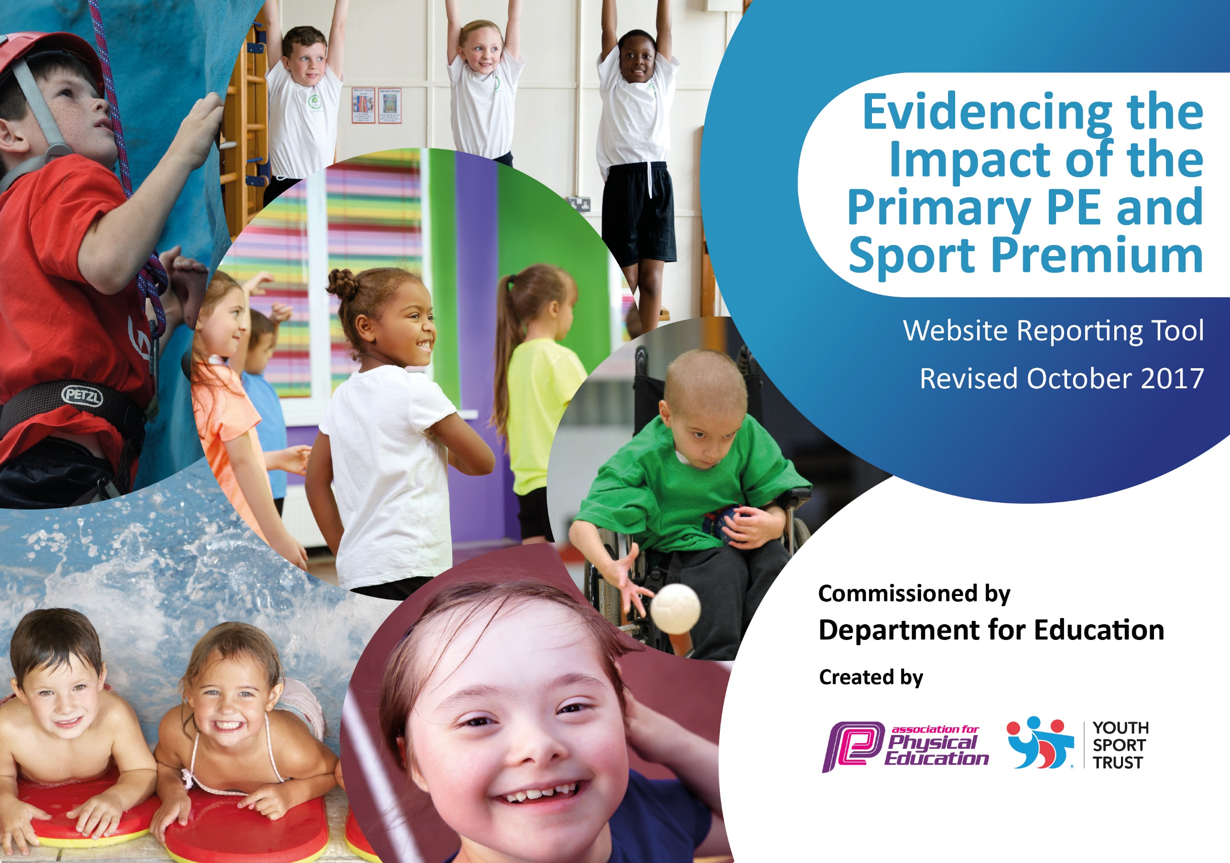
Evaluated Year 2018/19 Fairfield Primary School

Schools must use the funding to make additional and sustainable improvements to the quality of PE and sport they offer. This means that you should use the Primary PE and Sport Premium to:

- develop or add to the PE and sport activities that your school already offers
- build capacity and capability within the school to ensure that improvements made now will benefit pupils joining the school in future years

Please visit gov.uk for the revised DfE guidance including the 5 key indicators across which schools should demonstrate an improvement. This document will help you to review your provision and to report your spend. DfE encourages schools to use this template as an effective way of meeting the reporting requirements of the Primary PE and Sport Premium.

We recommend you start by reflecting on the impact of current provision and reviewing the previous spend.
Under the Ofsted Schools Inspection Framework, inspectors will assess how effectively leaders use
the Primary PE and Sport Premium and measure its impact on outcomes for pupils, and how effectively governors hold them to account
for this.

Schools are required to publish details of how they spend this funding as well as on the impact it has on pupils’ PE
and sport participation and attainment.
We recommend regularly updating the table and
publishing it on your website as evidence
of your ongoing review into how you are using the money
to secure maximum, sustainable impact. To see an example of how to complete the table please click HERE.

Support for review and reflection - considering the 5 key indicators from DfE, what development needs are a priority for your setting and your students now and why? Use the space below to reflect on previous spend, identify current need and priorities for the future.

Key achievements to date: | Areas for further improvement and baseline evidence of need:
Sports competitions and results 2018/19:  Level 1 High Netball 3rd Place 2018  Level 1 Sportshall athletics Champions 2018  Level 2 Sportshall athletics 5th place 2019  Year 6 football Cockermouth School competition Champions 2019  Level 2 Quick Sticks Hockey Regional Champions 2019  28 Children participate in Country Cross Country Competition. One Child finished 3rd and selected to compete in National Cross Country competition representing Cumbria. Year 5 girls team County Champions February 2019.  Level 2 Quicksticks Regional Champions February 2019  Year 6 Tag rugby Champions March 2019  Level 1 Year 4 tennis runners up March 2019  Rotary Football Competition Champions May 2019  Year 3 Mass participation Cross Country competition 52 children involved May 2019  Year 3 Mass participation rounders competition 52 children involved June 2019  Girls Cricket Competition June 2019  Level 1 Cricket Competition runners up June 2019  Cross Country Tri- Series finished 3rd overall with wins in individual categories over the series.  Touch rugby competition champions winning all categories Year 3/4 Boys, 5/6 Boys and Also 1st and 2nd Teams in the KS2 girls competition.  Level 3 County Quick Sticks Champions July 2019  ‘Active Education’ Cumbria County Winners 2019  ‘Healthy School of the Year’ National Winners 2019 | Within the upcoming academic year, we will strive to ensure that there is an increase staff CPD through twilight training in order to refresh their knowledge of core sports namely High 5 Netball, Sportshall athletics, Tennis, Hockey and Cricket (Level 1 and 2) for upcoming competitions.  Ensure Swimming is progressive and encompasses all that children need, above and beyond that offered in the curriculum to ensure children are competent swimmers leaving out school.  Develop progressive athletics program 5 steps, 5 stars.  Host CPS sessions for staff with external participants.  Develop knowledge and understanding of inclusive sports i.e wheel chair casketball.  We will continue to build upon children’s involvement in regular activity through use of durable and effective play time boxes designed and organized by the school council that will be monitored by sports leaders.

Meeting national curriculum requirements for swimming and water safety (for year 2017/18) | Please complete all of the below:
What percentage of your Year 6 pupils could swim competently, confidently and proficiently over a distance of at least 25 metres when they left your primary school at the end of last academic year? | 96%
What percentage of your Year 6 pupils could use a range of strokes effectively [for example, front crawl, backstroke and breaststroke] when they left your primary school at the end of last academic year? | 96%
What percentage of your Year 6 pupils could perform safe self-rescue in different water-based situations when they left your primary school at the end of last academic year? | 98%
Schools can choose to use the Primary PE and Sport Premium to provide additional provision for swimming but this must be for activity over and above the national curriculum requirements. Have you used it in this way? | Yes

Action Plan and Budget Tracking
Capture your intended annual spend against the 5 key indicators. Clarify the success criteria and evidence of impact that you intend to measure to evaluate for students today and for the future.

Academic Year: 2018/19 | Total fund allocated: 18,000  Total fund outlined below: £18,000 | Date Updated: 14/10/18
Key indicator 1: The engagement of all pupils in regular physical activity – Chief Medical Officer guidelines recommend that primary school children undertake at least 30 minutes of physical activity a day in school |  |  |  | Percentage of total allocation:
 |  |  |  | £3500 20%
School focus with clarity on intended impact on pupils: | Actions to achieve: | Funding allocated: | Evidence and impact:  To be reviewed 2019/20 | Sustainability and suggested next steps:
Develop play provision.  ‘Walk Wednesdays’ promoted throughout KS1 and KS2.  Active Families based on parent’s feedback.  1K a Day | Allocated play time leaders will be involved in organising durable boxes with suitable equipment for each year group that can easily be accessed. Develop KS1 provision.  In class target boards personalized to each class that will be shared termly in assembly.  Use of the Feet First Programme/ Hands Up Survey to encourage use of different modes of transport to get to and from school.  Timetabled sessions that are devised with families personal targets as a key focus for each session.  Continue whole school involvement in 1K a day. | £2500  £0  £1000  £0 | Playboxes and new sheds in place in KS1 and KS2. Equipment purchased. Active playtimes.  Feet first and scoot to school project completed. Many parents do walk and lots of children scoot. It may not be appropriate to have a nominated day to walk as this does not suit all parents requirements.  Active families continues on Saturdays in conjunction with Wright Sports Services/Chance Camp. | Sheds will last a long time, however more equipment will be needed and it will need to be more durable, sustainability.  Continue with Feet First and Scoot programs. Free and sustainable.  This project is working well with the community links. Wright Sports Services/Chance Camp continue to do an amazing job in the delivery and this will continue in 2019/20.
Key indicator 2: The profile of PE and sport being raised across the school as a tool for whole school improvement |  |  |  | Percentage of total allocation:
 |  |  |  | £2750 15 %
School focus with clarity on intended impact on pupils: | Actions to achieve: | Funding allocated: | Evidence and impact:  To be reviewed 2019/20 | Sustainability and suggested next steps:
Fully implement and utilise IPEP program, Maths of the day and 5-a-day across whole school.  Inter-house competitions are financially viable and can be developed to enhance in-school, inter-house competition.  Ensure continued use of Sports leaders for daily provision for all KS2 children and explore upskilling of Mid-day supervisors to enhance KS1 (and further enhance KS2 provision). | INSET day review training for all staff.  Focused staff meetings where year group partners can monitor children’s progress and amend planning for the sequential terms.  PE sessions timetabled for each year group cross referenced with class overviews and whole school timetable for competitions ( Chris Wright Services, Allerdale and Cockermouth School Competitions).  All coaches/ staff delivering core sports to organise both inter- house and inter- school competitions at the end of each block.  Potential to draw up a Key Stage league table for each year group to be shared and celebrated in Summer 2.  Bibs for each house colour.  CPD opportunities/ coaching for Mid-day supervisors so that they can timetable weekly activities for children in KS1 and deploy equipment appropriately using the play time boxes. | £2000  £250  £500 | Staff now use IPEP program, Maths of the day and 5-a-day across whole school. Staff meeting delivered to explain how to use the programs and time provided to updated IPEP assessment.  Completed in house competitions though league tables etc not shared. Aim to develop a league in 2019/20 and link with Sports Day to better monitor intra-school competition and whole school results.  Sports leaders deliver lunch time provision daily. Year 6 children have been amazing at this. Mid-day supervisors have not been involved as Year 6 children run the events. | Continue in 2019/20, sustainability.  Develop league table for 2019/20. Ensure Sports Board is updated with results.  Continue for 2019/20.

Key indicator 3: Increased confidence, knowledge and skills of all staff in teaching PE and sport |  |  |  | Percentage of total allocation:
 |  |  |  | £750 4%
School focus with clarity on intended  impact on pupils: | Actions to achieve: | Funding  allocated: | Evidence and impact:  To be reviewed 2019/20 | Sustainability and suggested  next steps:
Provide additional CPD opportunities for staff for Gymnastics and core skills.  To further implement Maths of the Day inside and outside of the classroom. | Core sports i.e. High 5, Quick sticks, Quick cricket, Sportshall Athletics, Tag rugby to be explored and enhanced during twilight sessions to develop staff awareness and understanding of how the sport is played providing an opportunity to refresh knowledge prior to the upcoming competitions in the school timetable.  Staff to record MOTD in children’s books and lessons to be shared with parents on class dojo. | £250  £500 | Not completed due to staff meeting availability.  This is widely used and evaluated through in school moderation/book scrutiny. | This is to be rescheduled for 2019/20.  Continue 2019/20
Key indicator 4: Broader experience of a range of sports and activities offered to all pupils |  |  |  | Percentage of total allocation:
 |  |  |  | £7,000 39%
School focus with clarity on intended  impact on pupils: | Actions to achieve: | Funding  allocated: | Evidence and impact:  To be reviewed 2019/20 | Sustainability and suggested  next steps:
Grand-day Out  Sports Development  Climbing Wall | A suggested £1 contribution to cover the cost of transport is required to ensure that the Grand Day Outs can take place.  Specialist coaches will continue to work alongside staff in school. They will work alongside the children to develop skills and also identify those who will benefit from after school sports development club.  Sports Leaders and Mid Day Supervisors will be responsible for ensuring the climbing wall is used effectively to develop gross motor skills across KS2.  KS1 staff will ensure that the children use the climbing wall to develop gross motor skills. | £1000  £6,000  £0 | Money used to subsides busses for Grand Day out.  This has been a core focus of 2018/19. Children and staff have benefitted hugely, this is represented in the hugely successful sporting year (as above).  The climbing wall is used daily by children across the school. There is no additional spend for this. | Continue in 2019/20.  Continue and ensure the link with Staff CPD for 2019/20, sustainability.  Continue for 2019/20 Climbing wall in place – sustainability.
Key indicator 5: Increased participation in competitive sport |  |  |  | Percentage of total allocation:
 |  |  |  | £4,000 22%
School focus with clarity on intended  impact on pupils: | Actions to achieve: | Funding  allocated: | Evidence and impact:  To be reviewed 2019/20 | Sustainability and suggested  next steps:
We will aim for 75 % of all children to participate in a competitive sport. | INSET DAY: share new arrangements for organising competitions where class teachers and specialist coaches will choose, select and take their own class to competitions.  Introduce new format of coaching and competitions for the whole year to all staff.  Participate in Allerdale, Cockermouth and Wright Sports Services Multi Skills and Football competition in addition to Level 2 Sports. | £500  £0  £3500 | 76% of all KS2 children represented the school in a sporting event. Target met. Competitions have been extensive this year with a high demand on staff and school resources. However, more children than ever are participating in school competition. | Target those ‘reluctant’ participants to ensure they are active, engaged. Ensure barriers are broken to ensure children who would not/have not participated have opportunity and a positive sporting experience.

